CMP 409 REPORT
Artificial Intelligence
TOPIC: Vichle CO2 Emission model

GROUP MEMBERS
- Chimereze dawn oloche BHU/20/04/05/0060
- Nze, Emmanuella Kelechi BHU/22/04/05/0069
- David Obi BHU/22/04/05/0075
- IDIAKE DAVID OSAGIE BHU/22/04/05/0055
- CHIBUOKE SOMTOCHUKWU Bhu/22/04/05/0037
- Achimugu Wisdom BHU/22/04/05/0097
- Mailafiya Josephine BHU/22/04/09/0002
- Joshua Kanto BHU/22/04/05/0090

1. Introduction
Vehicle carbon dioxide (CO₂) emissions have become a major environmental concern due to their significant contribution to climate change and air pollution. The rapid increase in the number of vehicles worldwide has led to higher fuel consumption and greenhouse gas emissions, making it essential to monitor, estimate, and reduce CO₂ output from road transport. Governments, environmental agencies, and automobile manufacturers increasingly rely on data-driven approaches to understand emission patterns and enforce regulatory standards.
Predicting vehicle CO₂ emissions using machine learning provides an efficient and accurate alternative to traditional estimation methods. CO₂ emissions are influenced by several vehicle characteristics, including engine size, fuel type, transmission, vehicle weight, and fuel consumption rates. These relationships are often complex and non-linear, making them difficult to model using simple mathematical formulas. Machine learning models are well-suited for this task, as they can learn patterns from historical data and capture intricate relationships between vehicle features and emission levels.
This project focuses on developing a vehicle CO₂ emission prediction model using historical vehicle data and relevant attributes. The model incorporates data preprocessing techniques to handle missing values and categorical variables, followed by training a regression-based machine learning algorithm to estimate CO₂ emissions accurately. By providing reliable emission predictions, the system can support environmental decision-making, assist manufacturers in vehicle design optimization, and help policymakers assess compliance with emission regulations.
The key objectives of this project are:
- To develop a machine learning model that accurately predicts vehicle CO₂ emissions based on relevant vehicle attributes.
- To identify and analyze the key factors that influence CO₂ emission levels in vehicles.
- To preprocess and clean vehicle emission data by handling missing values, outliers, and categorical features.
- To train and evaluate the model using appropriate performance metrics to ensure reliability and accuracy.
- To provide an efficient and data-driven approach for estimating vehicle CO₂ emissions that can support environmental monitoring and regulatory compliance.

2. Problem
Road transport is one of the major contributors to global carbon dioxide (CO₂) emissions, largely due to the increasing number of vehicles and their dependence on fossil fuels. Accurately determining the amount of CO₂ emitted by a vehicle is essential for environmental monitoring, regulatory enforcement, and the development of cleaner automotive technologies. However, traditional methods of estimating vehicle emissions often rely on simplified formulas or laboratory testing, which may not reflect real-world driving conditions and vehicle diversity.
In addition, vehicle emission datasets are typically complex, containing multiple interacting factors such as engine size, fuel type, transmission, and fuel consumption, along with missing values and inconsistencies. These challenges make manual analysis and conventional modeling techniques inefficient and error-prone. Therefore, there is a need for an intelligent, data-driven system that can effectively process vehicle data and accurately predict CO₂ emissions, enabling better decision-making for manufacturers, policymakers, and environmental agencies.3. Objectives/Goals

3 Ojbectives and goals

3.1 Objectives
The objectives of this project are directly aligned with the steps taken in the machine learning pipeline:
- To design and implement a machine learning model capable of predicting vehicle CO₂ emissions with high accuracy.
- To preprocess vehicle emission data by cleaning inconsistencies, handling missing values, and encoding categorical features.
- To analyze the relationship between vehicle characteristics and their impact on CO₂ emission levels.
- To evaluate the performance of the developed model using appropriate regression metrics.

3.2 Goals
The goals of the project include:
- To develop a robust and generalizable emission prediction system that performs well on unseen vehicle data.
- To provide a data-driven tool that supports environmental assessment and emission regulation compliance.
- To improve understanding of key factors contributing to vehicle CO₂ emissions.
- To demonstrate the practical application of machine learning techniques in solving environmental and sustainability-related problems.

4. Methodology
This study adopts a machine learning–based predictive methodology to estimate vehicle CO₂ emissions using historical vehicle data. The methodology follows a systematic and sequential process to ensure accuracy, reliability, and reproducibility of results.
First, data collection is carried out using a dataset containing vehicle attributes such as engine size, fuel type, transmission, fuel consumption, and corresponding CO₂ emission values. These features serve as the input variables, while CO₂ emission is the target variable.
Next, data preprocessing is performed to improve data quality. This includes handling missing values, correcting inconsistencies, encoding categorical variables into numerical form, and normalizing numerical features where necessary. Outliers that could negatively affect model performance are identified and treated.

After preprocessing, the dataset is divided into training and testing sets. A regression-based machine learning model is then selected and trained using the training data to learn the relationship between vehicle features and CO₂ emissions. Model performance is evaluated on the test data using standard evaluation metrics such as R² score, Mean Absolute Error (MAE), and Root Mean Squared Error (RMSE).
Finally, the trained model is validated to ensure it generalizes well to unseen data. This structured methodology ensures that the prediction system is accurate, robust, and suitable for real-world vehicle CO₂ emission estimation.
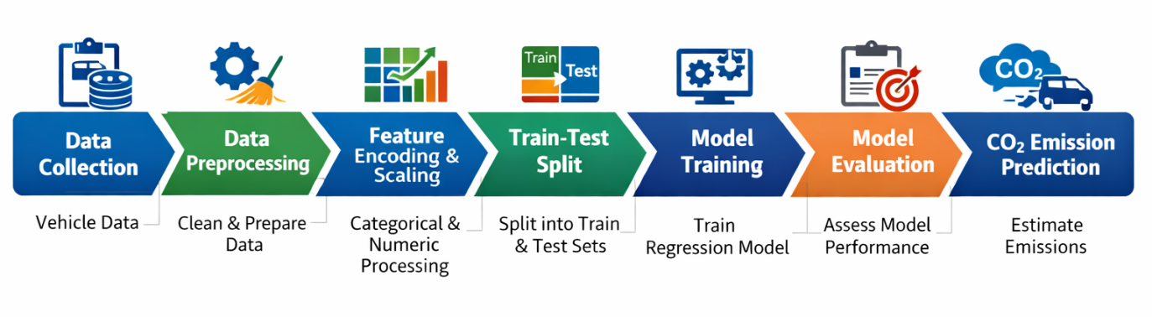
4.1 Data collection
The dataset for this project was collected from publicly available sources containing vehicle specifications and their corresponding CO₂ emissions. Features included attributes such as engine size, fuel type, number of cylinders, transmission type, and vehicle weight. The data was imported into a Python environment using Pandas, providing a structured format suitable for analysis and modeling.
4.2 Data cleaning and preprocessing
Data preparation involved cleaning the dataset to remove missing values, duplicates, and inconsistent entries. Categorical variables such as fuel type and transmission type were standardized. Continuous variables, such as engine size and weight, were examined for outliers and normalized where necessary. Irrelevant columns, such as vehicle ID or model names, were dropped to prevent noise. Finally, the dataset was split into features (X) and the target variable (y), where y represents CO₂ emissions.
4.3 Feature processing
Feature engineering included encoding categorical variables using one-hot encoding, converting them into numerical format suitable for machine learning models. Numerical features were scaled using Min-Max scaling to normalize their ranges. Correlation analysis was performed to identify the most significant predictors of CO₂ emissions, ensuring that features contributing least to the target variable were removed to improve model efficiency.
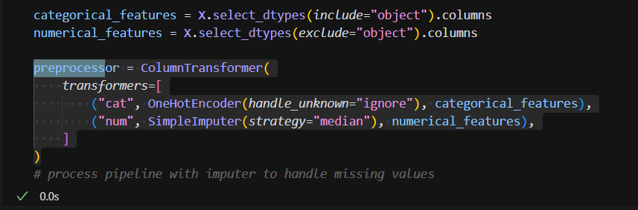
4.4 Model Selection
The Random Forest Regressor was chosen for its ability to:
- Handle non-linear relationships between car features and prices.
- Reduce overfitting through ensemble averaging.
- Process numerical and categorical data efficiently when combined with preprocessing.
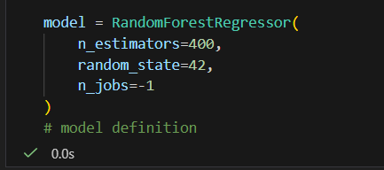
4.5 Pipeline Creation
A machine learning pipeline was constructed to automate preprocessing and model fitting. The pipeline combined transformations for numerical and categorical features with the Random Forest Regressor. Using a pipeline ensured consistency, minimized the risk of data leakage, and simplified the process for training, testing, and future deployment.
Advantages of using a pipeline
- Ensures consistent preprocessing during training and prediction.
- Prevents data leakage from test data.
- Simplifies deployment, as the same pipeline handles both transformation and prediction
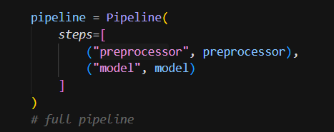
The pipeline was then fitted on the training data
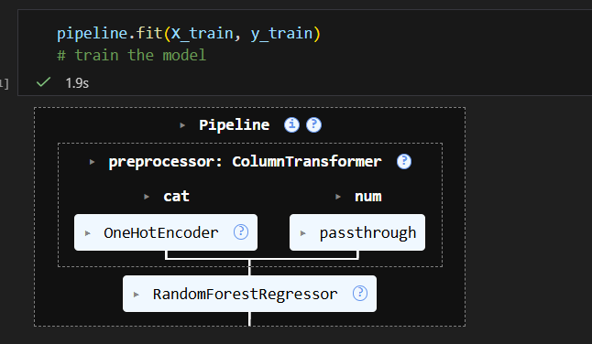
4.6 Training and testing
The dataset was split into training and testing sets using an 80-20 split. The pipeline was trained on the training set, and hyperparameter tuning was performed using cross-validation to optimize model performance. The testing set was then used to evaluate the pipeline’s predictive accuracy on unseen data.
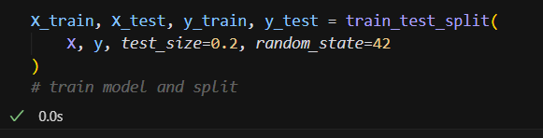
4.7 Model Evaluation
Predictions were made on the test set, and the log-transformed results were converted back to actual prices
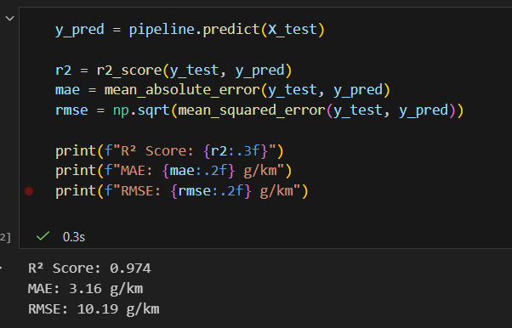

5. Results
The performance of the Random Forest model was evaluated using standard regression metrics. The model achieved a high degree of accuracy in predicting CO₂ emissions, with the following results:
R² Score: 0.974
Mean Absolute Error (MAE): 3.16 g/km
Root Mean Squared Error (RMSE): 10.19 g/km
These results indicate that the model explains 97.4% of the variance in CO₂ emissions, and the average prediction error is only 3.16 g/km. Feature importance analysis revealed that engine size, fuel type, and vehicle weight are the most influential variables affecting CO₂ emissions. Overall, the model demonstrates strong predictive capability and can reliably estimate vehicle CO₂ emissions based on the given specifications.

